Project: Pizza Sales Analysis - Using MS SQL Server

Importing CSV File in MS SQL Server

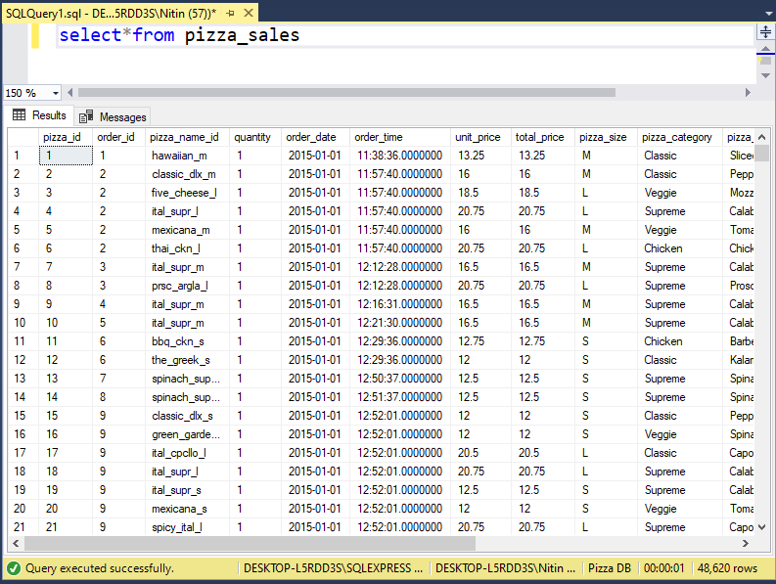

Total Revenue

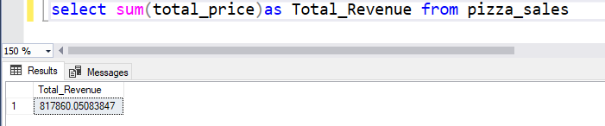

Average Order Value

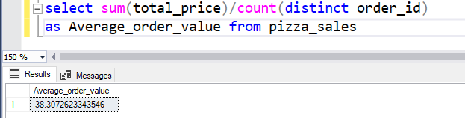

Total Pizza Sold

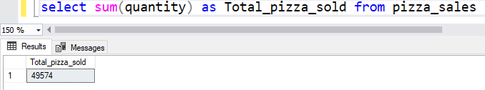

Total Orders

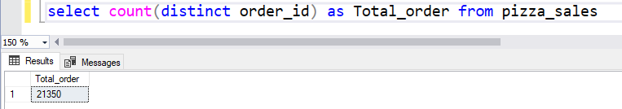

Average pizza per Order

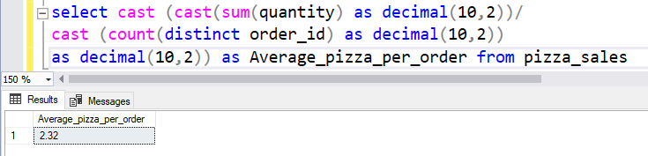

Daily Trends for Total Orders

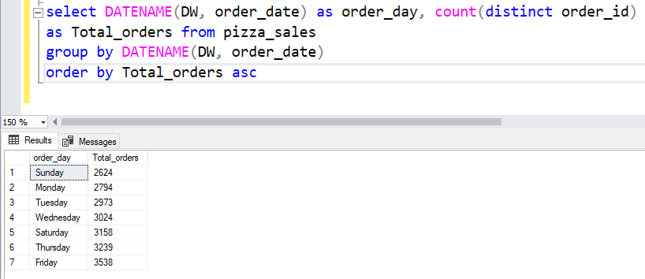

Monthly Trends for Total orders

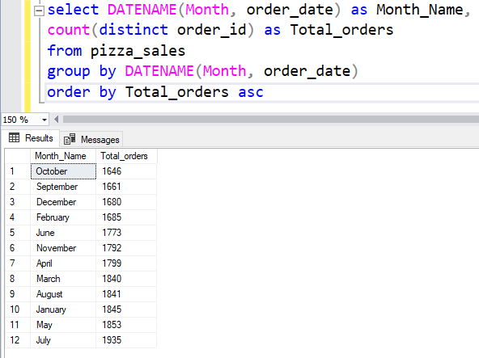

Percentage of Sales by Pizza Category

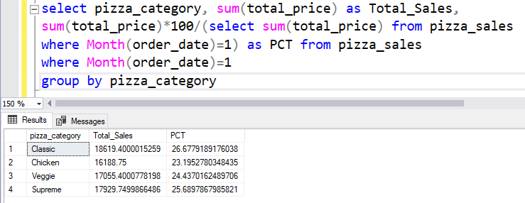

{“Here Month(order_date) = 1, indicates that the output is for the month of January.

Month(order_date) = 4, indicates output for the month of April”}

Percentage of Sales by Pizza Size

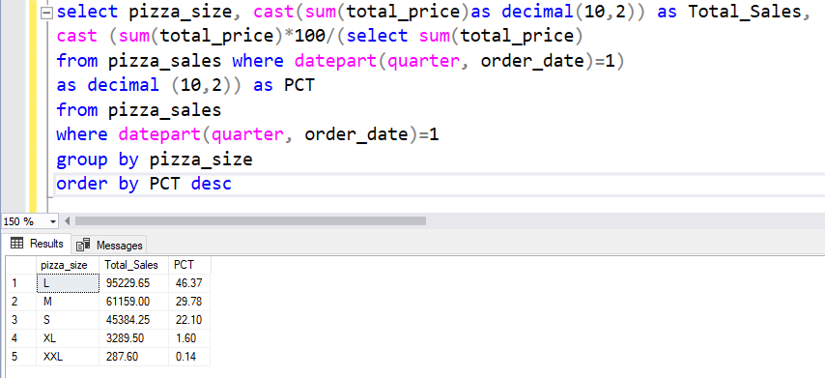

Top 5 Best Pizzas by Revenue

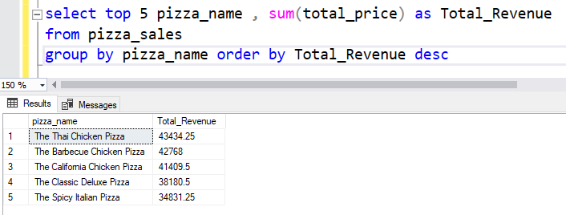

By Total Quantity

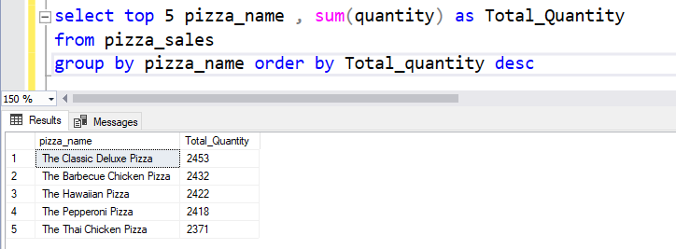

By Total Order

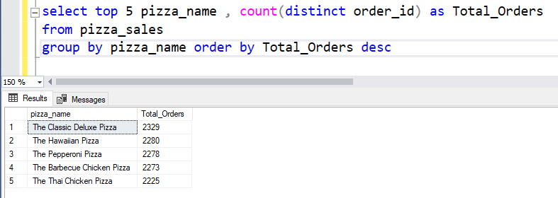

Bottom 5 Pizzas by Revenue

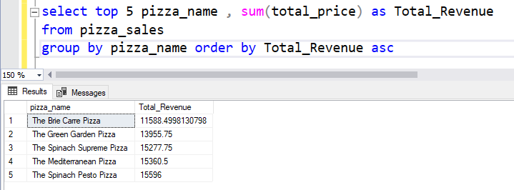

By Total Quantity

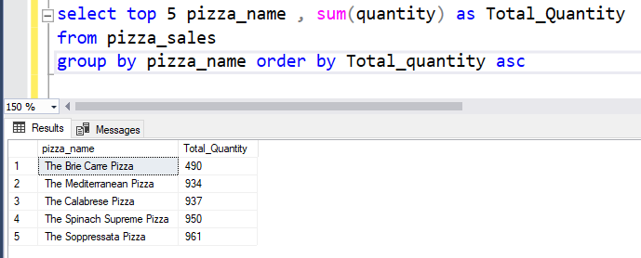

By Total Order

